PILOT RECORD FORM
AVIATION TRAINING
Personal Information | First and Last Name
 | Place of Birth
 | Date of Birth
 | Mother’s Name
 | Passport or ID#
 | Nationality
 | Address
 | Mobile Phone
 | E-Mail Address
Other Information | Gender
 | Present Employer
Emergency Contact: | Contact Name
 | Phone Number
 | E-Mail Address
Licenses, Medical and Language Proficiency | License Number |  |  | Type
 | Authority
 | First Issue |  |  | Validity
 | Medical Class |  |  | IR Checked?
 | Valid From |  |  | Valid to
 | ICAO English Level |  |  | Validity
 | English State or Internal Lang. Exam
Ratings | SEP Class Rating |  |  | Validity
 | IR Rating |  |  | Validity
 | MEP Class Rating |  |  | Validity
 | MEP-IR Rating |  |  | Validity
 | FI Rating |  |  | IRI Rating
 | MEP CR Instr.
 | Theoretical Course Completed:
 | MCC Course |  |  | Jet Fam
 | CRM Course |  |  | Validity
 | Type Ratings
 | Last LPC |  |  | Validity
 | TRI Rating |  |  | Validity
 | TRE Rating |  |  | Validity
 | TRE Issuing Authority
Flight Times | Total Flight Time |  |  | PIC
 | PIC Cross Country |  |  | Single Eng.
 | Multi Engine |  |  | IR Time
 | NIGHT Time |  |  | Simulator
 | Instructor Time |  |  | SIM Instr.
 | MPA PIC Time |  |  | MPA FO
 | TRI Time
 |  | Date
INSTRUCTION HOW TO FILL OUT THE PILOT RECORD FORM
First and Last Name | Write in this row your FIRST NAME and LAST NAME
Place of Birth | Indicate your place of Birth in the same format as in the ID/Passport
Date of Birth | Enter your date of birth (yyyy-mm-dd)
Mother’s Name | Enter your Mother's maiden name
Passport or ID# | Enter your present Passport or ID number
Nationality | Indicate your present nationality
Address | Enter your address (street name and number, city, state, country, postcode)
Mobile Phone | Type here your mobile phone (cell phone) number
E-Mail Address | Enter here the e-mail address, which you check regularly
Gender | Write here your gender according to ID/Passport
Present Employer | Indicate the name of your present employer, and your current occupation
Contact Name | Write here your Emergency Contact name
Phone Number | Write here your Emergency Contact phone number
E-Mail Address | Write here your Emergency Contact E-Mail address
License Number, Authority | Enter your Pilot License’s Number, the type of license (PPL, CPL, ATPL, etc.) and the issuing Authority
First Issue, Validity | Enter the first issue and validity of the license
Medical Class, IR | Enter your Medical License class, and if you are IR checked or not (yes/no)
Valid From, Valid to | Enter the validity of the Medical Certificate
ICAO English Level | Enter your ICAO English level and its validity
English State or Internal Lang. Exam | Indicate your English State or International Language exam details (name, class, date)
SEP Class Rating | Indicate your Single Engine Class Ratings and its validity, and the date until your CR Inst. is valid
IR Rating | Indicate the date of the first issue of your IFR, its validity, and the issue of your IFR Instructor Rating
MEP Class Rating | Indicate the date of the first issue of your ME Rating, its validity, and the issue of your ME Instructor Rating
MEP-IR Rating | Indicate the date of the first issue of your ME-IR, its validity, and the issue of your MEIR Instructor Rating
FI Rating, IRI Rating | Indicate the data of you FI and IRI rating is valid
MEP CR Instr. | Indicate the data of your ME Instructor rating's validity
Theoretical Course Comleted: | Indicate the theoretical courses you have completed (IR Theory, CPL Theory, ATPL Theory)
MCC Course | Indicate the dates when you have completed the MCC Course and the Jet Familiarization Course
CRM Course | Indicate the date of the first issue of your CRM and its validity
Type Ratings | Detail your type ratings (only the types which requires Type Rating)
Last LPC | Indicate the date of your last PLC and its validity
TRI Rating | Indicate the date of the first issue of your TR Instructor rating and its validity
TRE Rating | Indicate the date of the first issue of your TR Examiner rating and its validity
TRE Issuing Authority | Indicate the Issuing Authority of your TR Examiner rating
Total Flight Time, PIC | Enter your total flight time and time as Commander
PIC Cross Country, Single Engine | Enter your total flight time as Commander on Cross Country Flights and the total flight time on single engine aircraft
Multi Engine, IR Time | Your total flight time on Multi engine aircrafts and under Instrument Flight Conditions
NIGHT Time, Simulator | Your total flight time under Night condition, and the total time on simulator
Instructor Time, SIM Instr. Time | Your total flight time as Instructor and Simulator Instructor
MPA PIC Time, MPA FO Time | Indicate your total flight time on Multi Pilot Aircraft as Commander and as First Officer
TRI Time | Indicate your total flight time as TRI
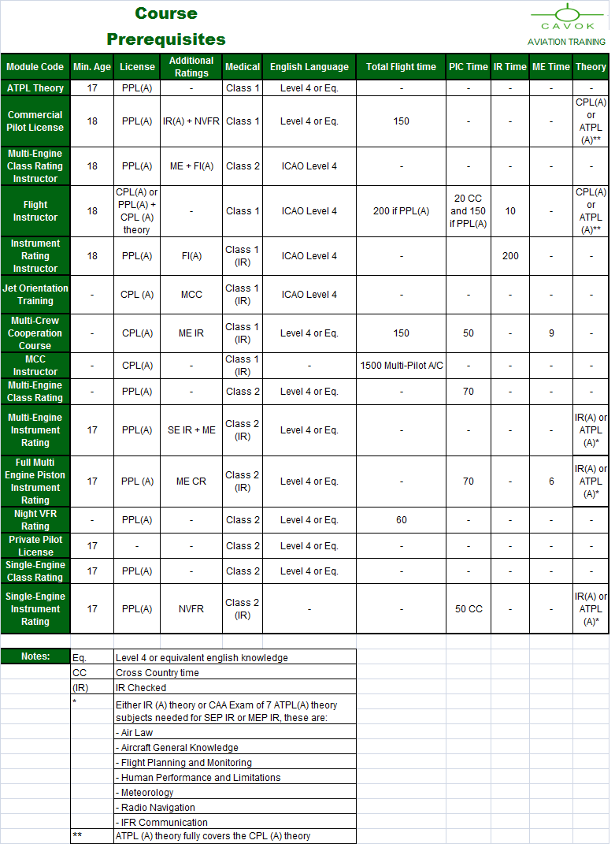

Form V8

